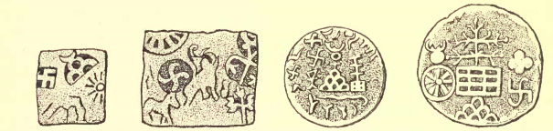
Ancient Hindu coins. Waring, “Ceramic art in Remote Ages,” pl.41, figs. 20-24

